Media Release
For immediate release
The dynamics of a $9.5 trillion Australian super system: Deloitte projects the next 20 years

17 November 2015: Using a comprehensive demographic and financial analytic tool, Deloitte Actuaries & Consultants modelled the future progress of the Australian superannuation industry over the next 20 years. Projecting a $9.5 trillion system, the report highlights its components, projects their growth, and comments on the market dynamics, demographic shifts, longevity challenges and adequacy of the world’s fourth largest super asset pool.

With current total assets of $2 trillion, the pool of the Australian superannuation system is projected to double to $4 trillion in the next 10 years and reach $9.5 trillion by 2035. Deloitte Superannuation Leader, Russell Mason, said in real terms this means that the contribution of superannuation assets will almost double from 120% of current annual Gross Domestic Product (AUD$1.6 trillion - the 12th largest GDP in the world) to more than 200% of GDP in the next 20 years.

“These cumulative projections reflect the legislated increases in the Superannuation Guarantee (SG) from 9.5% to 12% by July 2025, with the next increase (to 10%) scheduled from 1 July 2021. However, given the current low interest rate environment and volatile super fund returns, there are material sequencing risks for retirees,” Mason said. “Given that annual earnings have not been adequate to sustain living needs, or minimum drawdown requirements, many retirees have had to draw down greater proportions of their retirement savings, potentially curtailing previously projected growth in post-retirement assets which we now project to be $1.6 trillion in 2035.”

Total superannuation assets to 2035

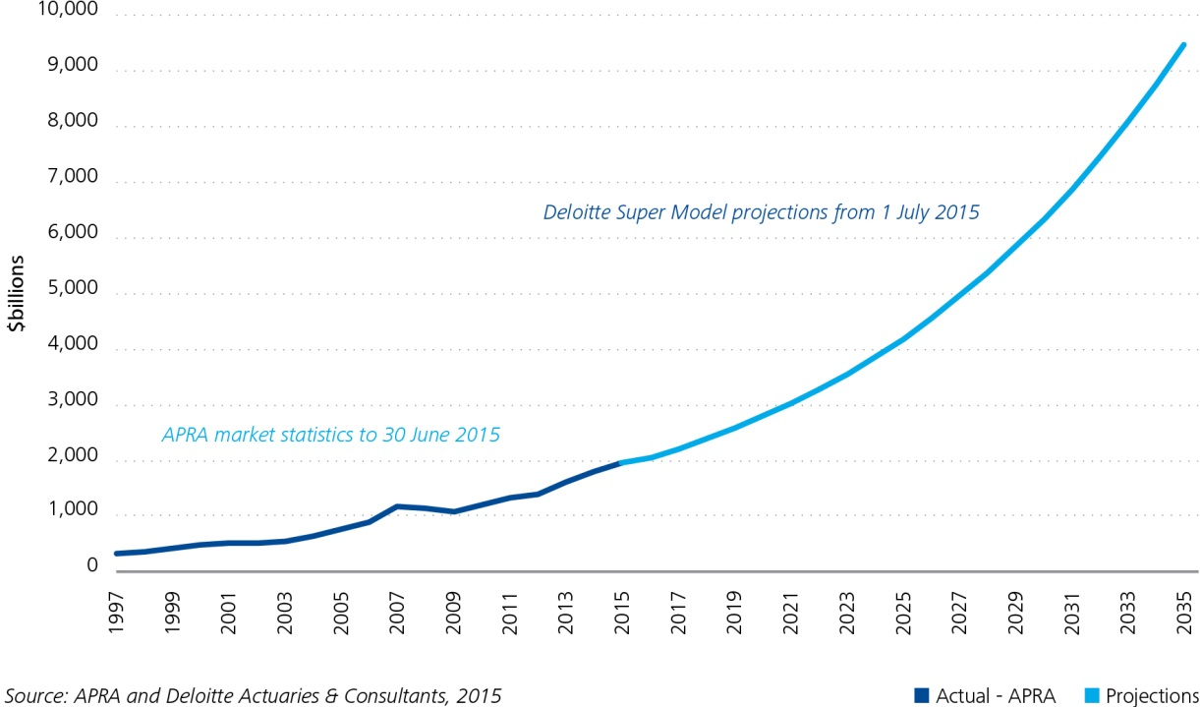

Concessional contribution and lifetime cap proposals
Mason said: “Our research highlights significant changes in longevity. The proportion of retirees to working Australians has almost doubled in the past 60 years. Currently there are four and a half workers for every retiree in Australia. By 2050 we believe this will drop to just two and a third workers for each retiree. This means finding revenue to support the aged pension and building ways to achieve adequacy in retirement have never been more important.

“To help manage these critical issues we propose underpinning the SG with effective concessions and incentives for voluntary contributions, including concessional contribution caps based on joint incomes and/or lifetime contribution caps. Our modelling shows such concessions would be potentially less expensive for the Government after considering expected savings in age pension payments. Assuming a typical default investment fund and normal investment outcomes, with most voluntary contributions made after age 45, a lifetime contribution cap of $580,000 would be sufficient.”

SG, taxation, working longer and education
Ben Facer, Deloitte Actuaries & Consultants partner who helped build the research said: “We support increasing the Superannuation Guarantee to 12% as quickly as possible as current superannuation benefits for most Australians at retirement won’t be sufficient to sustain a ‘reasonable’ or ‘comfortable’ standard of living without relying on the age pension, at least in part. This means that most Australians, if able, will need to delay their retirement and work even longer than the new age pension eligibility age of 67 years.”

Mason added: “As with our Deloitte Access Economics research (see Mythbusting Tax reform #2) we also recommend the Government consider taxing contributions at the top marginal rate less 15%, hence cutting contribution tax for lowest income earners to a rebate overall and doubling tax to 34% for those earning between $180k and $300k. According to the research this would raise $6 billion in the 2016-17 fiscal year.

“By revisiting incentives via the tax system we want to encourage retirees to draw-down their superannuation as annuities, account-based pensions or other types of products to provide a stable income during retirement. We also vigorously support continuing advancements in education and advice (see our Advice Based World research released earlier this year).”

Investment returns
The report shows that investment returns on superannuation assets remain a significant contributor to the growth of the superannuation industry. Facer said: “In the past three years there has been a return to the trend for net investment income to at least equal total net superannuation contributions. However, we do project a plateauing of net cashflows from around 2030, and possibly the hint of a drop at the tail end of the projection period.”

The system is still maturing

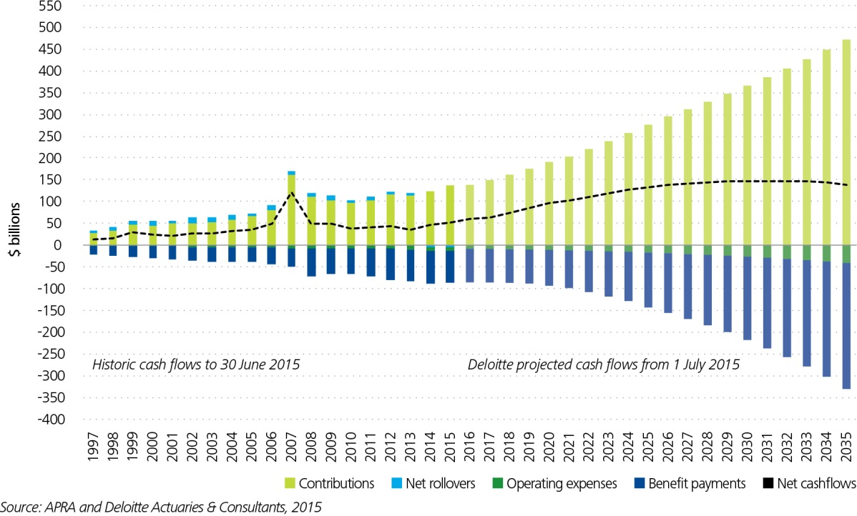

Facer said: “It is important that members do not invest too conservatively in the early to middle years of their working lives, so they can maximise the impact of investment returns compounding up to and into retirement. Given that superannuation is preserved for retirement, these members will be able to withstand the short-term volatility inherent in growth-oriented portfolios and achieve a higher long-term average return overall.

“As total superannuation assets continue to grow larger, relative to the size of the Australian economy, this will increase pressure on the investment capacity of funds and will drive increased investments in alternative assets and across all asset classes in overseas markets. This puts a renewed focus on the Asia Funds passport arrangements for our region.”

Sector growth: superannuation assets by market segment 2015-2035

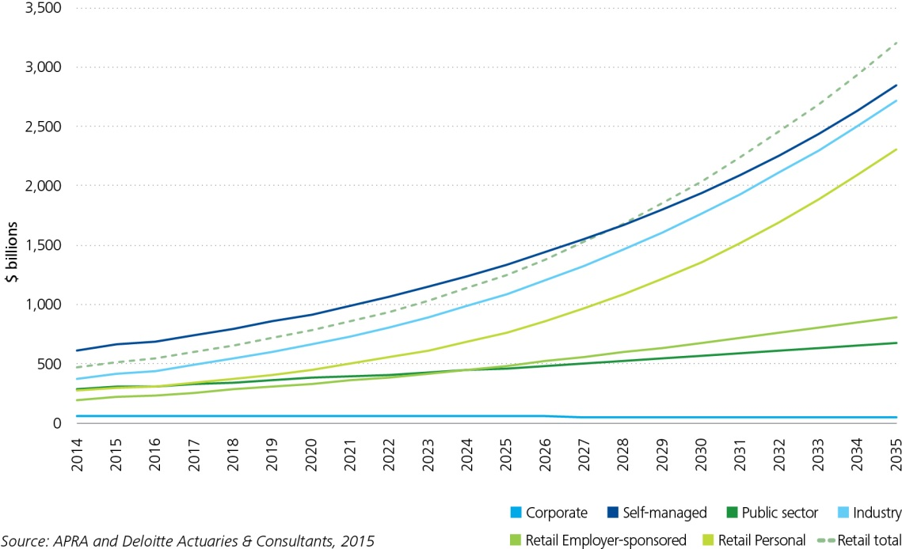

The research compiled the movement of total assets in each segment from 1997 to 2015 from APRA data and then used the Deloitte Super Model to project movement from 2015 to 2035. Some highlights from these projections include:

- Growth: Industry funds and retail funds are expected to grow significantly over the next 20 years with similar rates of overall growth, and slightly above the rate of growth of Self-Managed Superannuation Funds (SMSFs).
- Retail largest overall: The total retail fund sector (a combination of retail employer sponsored and retail personal) will take over from SMSFs as the largest market segment in 2028 and reach $3 trillion in assets in 2034.
- SMSFs – post retirement bulge: SMSFs are still expected to be the largest sector by far in the post-retirement superannuation market, reaching $900bn in 2035, and eclipsing the retail segment in 2018.
- Industry and retail funds: It is not yet clear how successful industry funds and the large wealth management businesses will be in curtailing the rapid growth in post-retirement assets for SMSFs.
Facer said: “There is considerable scope for funds to capitalise on the opportunity to develop new initiatives to capture a greater share of that market, such as providing members with more individual flexibility. Those that do this well will be most successful in retaining and growing their market share.”
- Public sector: Public sector funds are expected to continue to grow at a reasonable rate over the period, while the corporate segment will continue to slowly decline.

Facer said: “Although industry funds will become the largest pre-retirement sector by around 2025, Retail Personal will also continue to grow strongly, reflecting the power of the banks and their distribution networks. If it stays on the current trajectory, Retail Personal will become the second largest pre-retirement sector around 2033.

“SMSFs are popular, although less so in the pre-retirement phase than post-retirement, where they dominate. People are tending to create their own SMSF on retirement or earlier, particularly if leaving employment with a large benefit entitlement from their existing superannuation fund (such as current corporate or public sector plan).

“The sense that SMSFs offer greater control over superannuation returns, and for those members with larger account balances, the ability to harness the flexibility of family-based accounts, are attractive incentives. This suggests that, with the tax benefits available within an SMSF structure for those transitioning from pre-retirement to post-retirement, post-retirement SMSF assets will continue to grow.”

SMSFs to dominate in post-retirement space

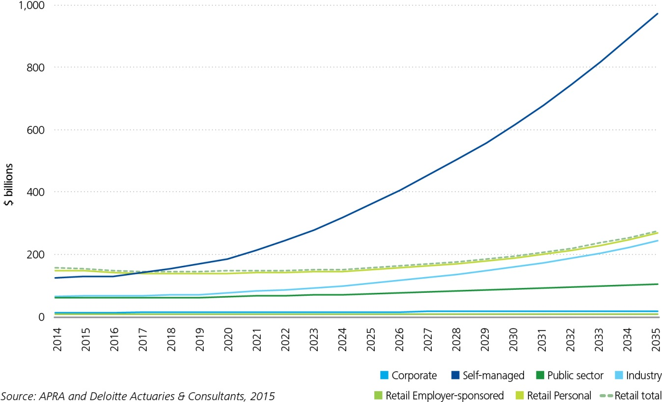

Benefit adequacy
Mason said: “It is widely recognised that SG contributions alone are insufficient to produce an adequate retirement income for a typical retiree. When Paul Keating first designed the superannuation system in the early 1990s, he intended compulsory contributions to reach 15% of salary – 12% from employers and 3% from employees.

“We’ve come a long way since then, particularly in longevity. Deloitte conducted calculations for a typical 30 year old individual today, earning approximately $65,000 p.a. and with a current superannuation balance of $30,000 invested in a typical 70/30 balanced portfolio. In order to produce a retirement income equivalent to the ASFA Comfortable Standard lasting until their life expectancy, this individual would need to contribute at the rate of 17.4% in total, if they were male, and 19.5% if they were female.

“There is clearly a significant gap between compulsory and required contributions which is not being met by additional voluntary contributions by the majority of Australians.”

The Deloitte research findings highlight the need for industry and government to consider how best to replenish revenues, refresh strategy, and recalibrate costs including:

- Developing innovative products:
- Retail funds could leverage the inherent advantages of their sophisticated marketing techniques, branding and advances in social business.
- Industry funds could continue to give fund members the ability to invest directly in shares, deposits and fixed term assets, using data to develop personalised product and service offerings for default and choice members.
- Increasing education and emphasizing the value of after-tax returns from superannuation products relative to other investment vehicles.
- Introducing new investment options including innovative approaches to making income streams and annuities an attractive proposition to retirees.
- Boosting the population and the size of the asset pool through migration and increased working life and immigration (at working ages).

Mason concluded: “These are just some of the levers that business and government can pull to help manage the shifting dynamics of superannuation over the next twenty years and beyond.”

Highlights
- Increasing steadily to $9.5 trillion by 2035
- BUT most Australians will still rely in part on social security in retirement
- Post-retirement market will grow to $1.5 trillion by 2035. A large proportion of benefits will be drawn as a lump sum on retirement (or shortly thereafter)
- SMSFs continue to remain popular, especially in the post retirement phase
- Despite an ageing population, most funds will remain cash flow positive
- Adequacy is still a key issue as the number of retirees grow and the old-age dependency ratio doubles by 2015
- A lifetime cap is a solution and potentially less expensive for government.

For more information on the Dynamics of the Australian Superannuation System: the next 20 years, download the Report at www.deloitte.com/au/superannuation

NB: See our media releases and research at www.deloitte.com.au

For further information:
Russell Mason  Partner, Actuaries & Consultants  Deloitte  Tel: +61 2 9322 5347  rmason@deloitte.com.au | Ben Facer  Partner, Actuaries & Consultants  Deloitte  Tel: +61 2 9322 3493  bfacer@deloitte.com.au | Louise Denver  Director, Communications & Corporate Affairs  +61414 889857 /  +612 9322 7615  ldenver@deloitte.com.au
About Deloitte
Deloitte refers to one or more of Deloitte Touche Tohmatsu Limited, a UK private company limited by guarantee, and its network of member firms, each of which is a legally separate and independent entity. Please see www.deloitte.com/au/about for a detailed description of the legal structure of Deloitte Touche Tohmatsu Limited and its member firms.
Deloitte provides audit, tax, consulting, and financial advisory services to public and private clients spanning multiple industries. With a globally connected network of member firms in more than 150 countries, Deloitte brings world-class capabilities and high-quality service to clients, delivering the insights they need to address their most complex business challenges. Deloitte has in the region of 225,000 professionals, all committed to becoming the standard of excellence.
About Deloitte Australia
In Australia, the member firm is the Australian partnership of Deloitte Touche Tohmatsu. As one of Australia’s leading professional services firms, and winner of both the Australian Financial Review/CFO Audit Firm of the Year and Accounting Firm of the Year awards 2013, Deloitte Touche Tohmatsu and its affiliates provide audit, tax, consulting, and financial advisory services through approximately 6,000 people across the country. Focused on the creation of value and growth, and known as an employer of choice for innovative human resources programs, we are dedicated to helping our clients and our people excel. For more information, please visit Deloitte’s web site at www.deloitte.com.au.

Liability limited by a scheme approved under Professional Standards Legislation.
Member of Deloitte Touche Tohmatsu Limited
© 2015 Deloitte Touche Tohmatsu

These projections assume no changes in the current legislative environment applying to superannuation. However, given the current significant debate in the market and government we expect change is likely.

